T.C.
İSTANBUL ATLAS ÜNİVERSİTESİ
MÜHENDİSLİK VE DOĞA BİLİMLERİ
FAKÜLTESİ


Final report

Izzeldin Alashqar

Prof. doc. Naim ajlouni

Concept | Page number
Abstract | 3
Introduction | 3
Problem statement | 3
Goals and objectives | 12
Methodology | 13
Discussion | 23
Conclusion | 32
Figures and videos | 30

1. Abstract :
This report is about A submarine robotics project, that focuses on designing, developing, and deploying autonomous underwater vehicles (AUVs) to explore and operate in challenging aquatic environments. This initiative addresses real-world challenges, including marine research, environmental monitoring, and underwater infrastructure inspection.
The project emphasizes the integration of advanced technologies such as artificial intelligence, computer vision, and sensor fusion to enhance the vehicle's autonomous capabilities. Key features include precise navigation, adaptive decision-making, and robust communication systems suitable for harsh underwater conditions.
Through iterative design, simulation, and testing, the project seeks to achieve high efficiency in energy management, reliable data collection, and seamless remote control. Potential applications span diverse fields, such as oceanography, search and rescue missions, and subsea construction, contributing to advancing marine technology and sustainable ocean exploration.

2. Introduction:
The submarine built in the last 3 months had firstly divided the teams into 4 separate teams (Design, esp32, sensors, and command control) with 1 purpose: to make the submarine work. After testing the sensors, do the command control part, the connection between 2 esp32, connection of 2 esp32(connecting 3 sensors per esp32 and all do their different jobs), designing the shape of the submarine, functioning of sensors of esp32s and sensors before placement, and finally the placement of the electronics inside/ outside the submarine all by their favorite place or by other words best places for them to function well.

3. Problem statement
The problems we had in my point of view and full understanding of the project in total can be mentioned as follows:
( Sensors; what are they and why,/ numbers of esp32 and why,/ design presentation and steps of doing the design/ the selected scenario and more possible scenarios, and finally placement of sensors and why )

First: sensors
Totally, in this project, we had to use 8 sensors, which can be mentioned in the following table :
Sensor name | purpose | Usage in the project | General information
BMM150 | 3 axis manometer sensor, | serves as the compass of the submarine and considers its location in 3 axes can be referred to as (X, Y, Z) | The BMM150 serves as a 3-axis magnetometer sensor featuring an ultra-small form factor, less power consumption and lower noise. Ideal for a variety of altitude-tracking applications, this high-performance sensor also supports I2C/SPI interfaces and is compatible with 3.3V/5V. It can be easily integrated into projects such as GPS modules, wearables devices, audible devices, and drones, and is suitable for applications such as accurate altimeters, environment monitoring, and IoT projects.
Hb100 | Microwave Motion Sensor | , serves as motion detection in the submarine front of the submarine so it's high valuable water resistant sensor | The HB100 is a compact, low-cost microwave motion sensor module, designed for motion detection using the Doppler Effect. Operating at a frequency of 10.525 GHz, this sensor is ideal for detecting movement and speed. It finds applications in industrial, automotive, and security systems for detecting moving objects, speed, and even human presence. The HB100 is compatible with a variety of microcontrollers, including the ESP32.
. Feegow RC 300KV | BRUSHLESS MOTOR PROPELLER | usage in this submarine is the crucial part in the movement of the submarine itself ehich it serves as the motor and the propeller that generate the actual power for movement | , The Feegow RC 300KV brushless motor is a powerful model specifically designed for underwater vehicles, boats, and model ships. Offering low noise, high efficiency, and durability, this motor is a popular choice for underwater applications.With a speed rating of 300KV (RPM per volt) and an operating voltage range of 12V to 24V, it delivers reliable performance. Its brushless design ensures maintenance-free operation and a long lifespan.
MPU 6050 | 6 axis imu sensor | Track orientation, movement, and acceleration for navigation | The MPU-6050 is a 6-axis IMU sensor board frequently used in various hobby, multicopter, and robotic projects. The MPU-6050, equipped with a 3-axis gyro sensor and a 3-axis angular accelerometer, allows you to measure motion and orientation with precision. The MPU-6050 can be operated with a supply voltage between 3 and 5V, and thanks to the voltage regulator on the board, this voltage range offers wide compatibility. The MPU-6050's accelerometer and gyro outputs provide data through separate I²C channels. The MPU-6050, which can output with 16-bit high resolution on each axis, is ideal for precise data measurement.
Sen 0257 | water pressure sensor | calculate the water pressure | is a water pressure sensor that adopts a DFRobot Gravity 3-pin interface. It supports standard 5V voltage input and 0.5~4.5V linear voltage output. It is compatible with multiple Arduino controllers. Coordinate with a DFRobot Gravity IO Expansion Shield, the water pressure sensor can be plugged into an Arduino board, wiring-free. Put it with a Solenoid Valve, a Water Turbine Generator, and other sensors, you can build a smart water control system. Briefly speaking, this water pressure sensor is a stethoscope to a water pipe. It will help you to diagnose whether there is water, and how strong the water pressure is. It can be widely applied to smart home control systems (SCS), the Internet of Things (loT), and device detection
YF -S201 | ., water flow sensor | Measures the water flow | The YF-S201 Flow Sensor (Dataq part number 2000362) allows Dataq Instruments data acquisition and data logger units to acquire flow rate (L/sec) information. The combination of these two products provides a compact solution, with sensor excitation provided by the data logger. The logger itself allows data to be communicated to a connected PC over either a USB or Ethernet interface. Optionally, many data loggers can store data to a removable USB thumb drive to satisfy stand-alone applications. Even with a connected flow sensor, the data logger channel capacity allows additional channels of information to be acquired and correlated with flow information to satisfy nearly any level of measurement expansion.
AJ-SR04M | ultrasonic sensor | basically the eye of the submarine detect how far a single obstacle is from the submarine also works from high distances to 20 cm of the actual obstacle is
Pump switch | pump switch | , enters and releases water that will give the power to running the submarine works both ways both directions in and out
Second: numbers of esp32
After decision of the number of sensors and testing them individually, another problem concept has been raised which is trying to minimise the number of sensors per esp32 to make more place inside the submarine for other stuff rather than 8 esp32s for 8 sensors which the number was decided to be 4 esp32s and below is the division of the 4 esp32s with their wiring:

Here are the wiring configurations for each ESP32 board:
ESP32-1:
MPU6050 (12C):
BMM150(12C):
AJ-SR04M:
ESP32-2:
YF-S201 Water Flow Sensor:
SENO257 Pressure Sensor:
HB100 Doppler Sensor:
ESP32-3:
Connect the motor driver (e.g., L298N, TB6612, ESC) to ESP32-3:
IN1, IN2, PWM →GPIO25,GPIO26, GPIO27.
VCC→5V
GND →GND
ESP32-Master:
Connect all ESP32 boards using Serial Communication:
o TX(Slave ESP32)→ RX (Master ESP32)o RX(Slave ESP32)→ TX(Master ESP32)o GND → Shared GND

Third: design presentation:
The design wasn't introduced until mid-November of 2024, the design contains a half ball shaped head and dish shaped tail with 2 openings on the top of the body a bigger frontal sail and a smaller back rudder with 2 mid front down rudders, the design was finished and assembled in the early days of January 2025, the steps and the how it was done is by using a 3d printer, using the printer the team responsible for designing printed the parts piece by piece and all project members helped with gluing it together so it can be looking like the following figure:

Fourth: scenario
There were many scenarios in mind, but because of the limited places and resources we " as a team " tried to follow the following scenario:
Put the submarine inside a swimming pool and plant obstacles( eg water bottles) at different levels of the swimming pool and try to control it without having it to hit any obstacle and it must has the ability to move freely.
A more possible scenario is to put the submarine in the see and try to move it under sea which will be more harder to do because of density of the water and the salty water and lack of light under a certain level

Fifth: placement of scenarios
The following tables has the placement of scenarios and the reason for it
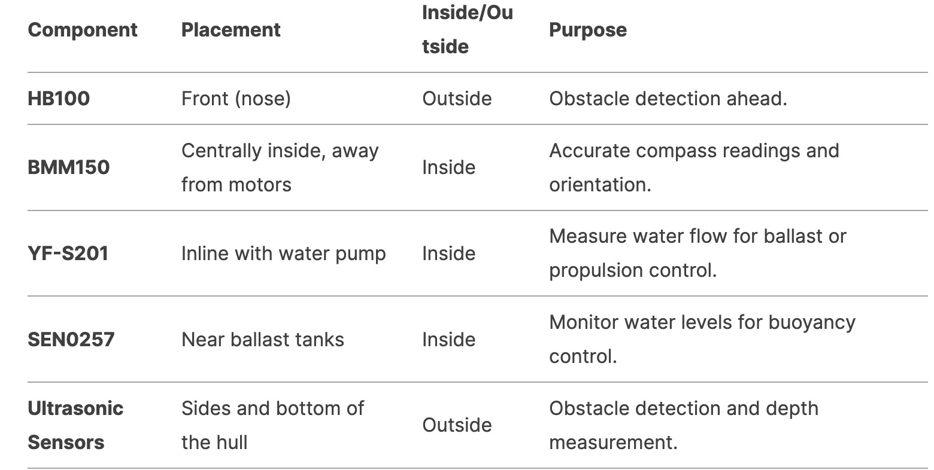
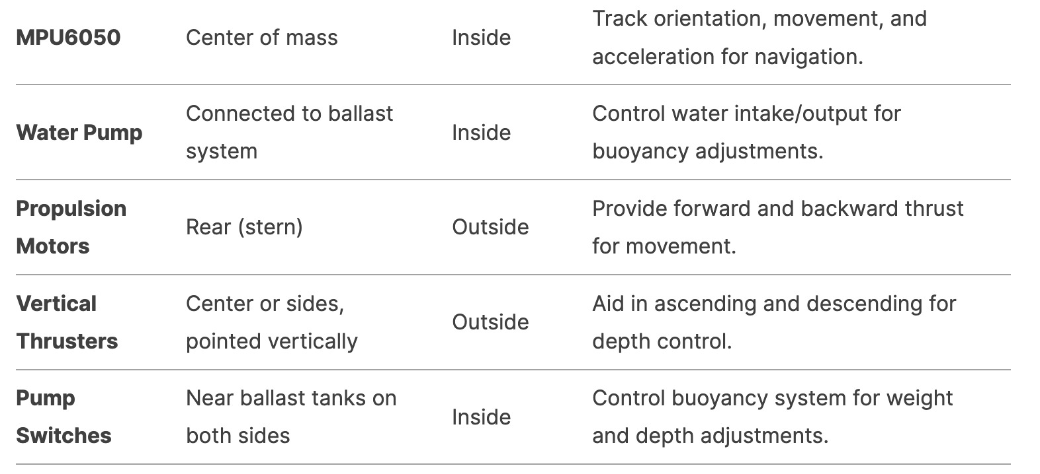
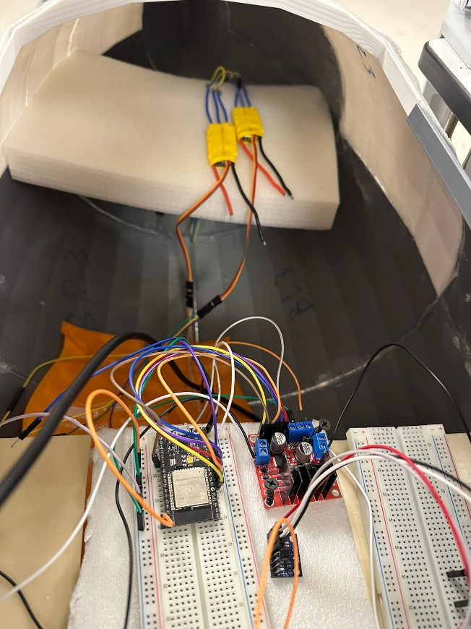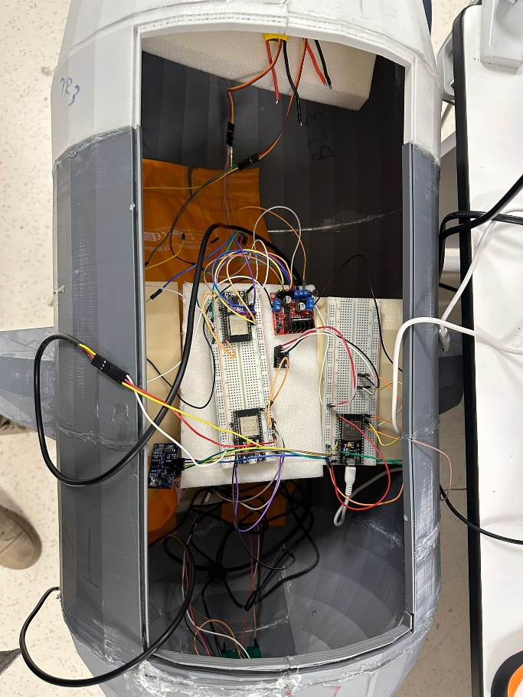

Sixth: prevent of leakage
For preventing water leakage we proposed the idea of water balloon and plastic bags to put the electronics in them to prevent any possible water leakage
4. Goals and objectives
Many goals and objectives were prepared for this project and it can be classified in these points :

Design and Development: Create a functional submarine capable of autonomous underwater navigation.
Sensor Integration: Ensure all eight sensors operate seamlessly to gather accurate data.
System Reliability: Develop robust systems for navigation, motion control, and data communication.
Testing and Validation: Perform extensive tests to evaluate performance and address shortcomings.
Finishing: all parts to be assembled in their place and show there functionality in a video

5. Methodology

Design Process

The submarine's body was designed using advanced 3D modeling software, as shown in the provided designs. The design was carefully optimized for strength, balance, and functionality while maintaining a streamlined shape for underwater efficiency.
Key Steps in the Design and Printing Process:
- 3D Modeling:
  - The body and components were modeled in Blender, with precise measurements and scaling to ensure compatibility with the electronic and mechanical systems.
  - Features such as fins, sensor mounts, and openings for thrusters were carefully incorporated into the design.
- Printing:
  - The submarine’s structure was fabricated using state-of-the-art 3D printing technology.
  - High-strength and waterproof filament materials were selected to ensure durability and water resistance.
  - The printing process was divided into segments for modularity, making assembly and modifications easier.
- Post-Processing:
  - After printing, the parts were assembled and bonded with waterproof adhesives.
  - Additional waterproofing measures, such as sealing gaps and applying protective coatings, were implemented to prevent water ingress during underwater operations.
- Component Integration:
  - The interior layout was designed to accommodate the electronics (e.g., sensors, control boards, and power systems) while maintaining proper balance.
  - Openings were incorporated for sensors like sonar, pressure sensors, and cameras, as well as propulsion systems like brushless motors.
Final Assembly: The fully assembled submarine body ensures:
- Streamlined Design: Minimizes drag during underwater movement.
- Structural Integrity: Can withstand water pressure and rough conditions.
- Functional Integration: Seamlessly incorporates electrical and mechanical systems, providing a reliable platform for underwater exploration.

Design From Side
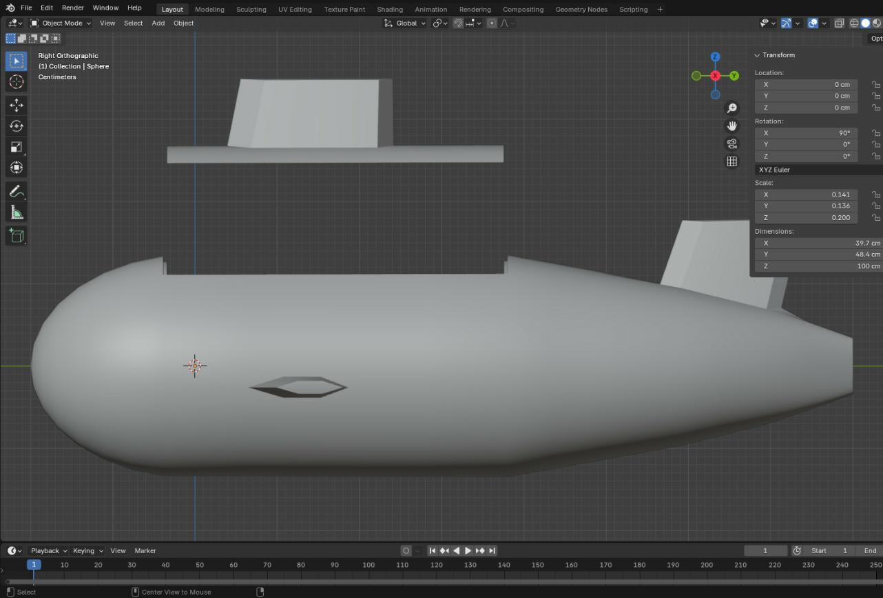
Design From Upside
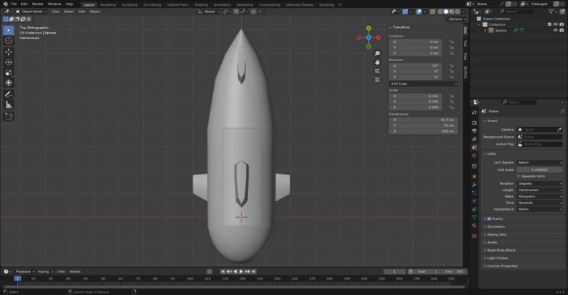
Design From an angle
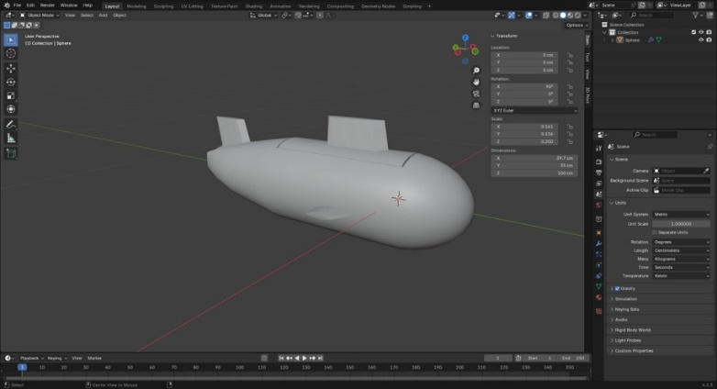
Sensor | Price and Link | Description | Placement
SEN0257 Pressure Sensor | https://www.robotistan.com/gravity-analog-water-pressure-sensor  10000 TL (30$) | Measures Water Sensor in range 0-1.6 Mpa
  Inside the hull, near the base
HB100 Radar Sensor | https://www.robotistan.com/hb100  130 TL (5$) | To detect objects and obstacles in the  submarine’s vicinity for safe navigation. | Mounted Externally
MPU6050 Gyroscope | https://www.robotistan.com/mpu6050-6-  100 TL (3$) | The accelerometer measures linear acceleration along the X, Y, and Z axes.  It detects changes in position or speed. | Centrally placed inside the hull
Ultrasonic Sensors | https://www.robotistan.com/jsn-sr04t-  167 TL (4$) | To provide precise distance measurements for obstacle avoidance. | Centrally placed inside the hull
YF-S201 Flow Sensor | https://www.robotistan.com/su-akis-ve-  125 TL (4$) | To measure water flow rates and verify system functionality. | Front and side of submarine
BMM150 Magnetometer | https://tr.aliexpress.com/i/1005008005873829.html  276 TL (8$) | To measure magnetic fields, aiding in directional navigation. | Inline with the water intake system
Brushless Motors | https://www.amazon.co.uk/Feegow-Brushless-  2-1700 TL 50 $ | To provide efficient propulsion and precise maneuverability. | Outside the hull
Esp32 Cam | https://www.robotistan.com/esp32-cam-wifi-bluetooth-  480 TL (25$) | To stream real-time video, which is essential for monitoring the underwater environment from the submarine. | Front and sides of the submarine

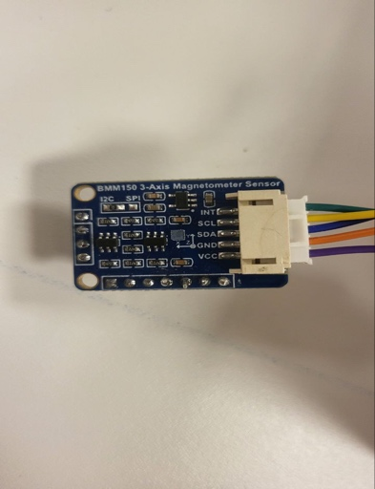  BMM 150 | 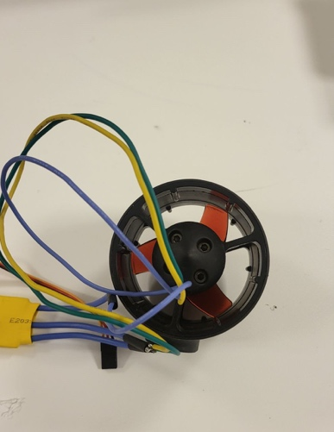  Brushless Motor | 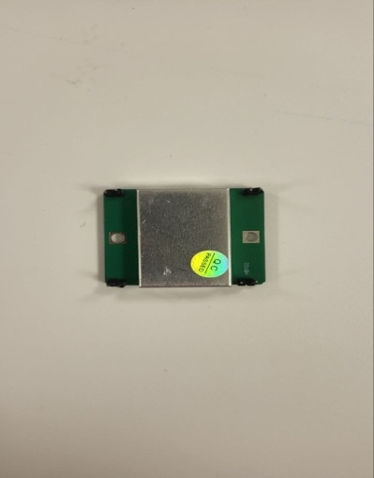  HB100 (DOPLAR)
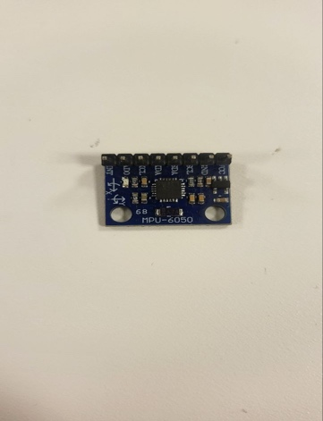  Mpu6050 | 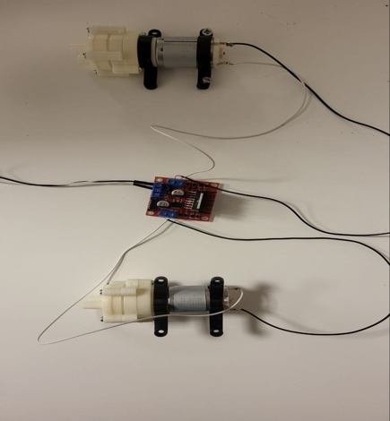  Pump switches | 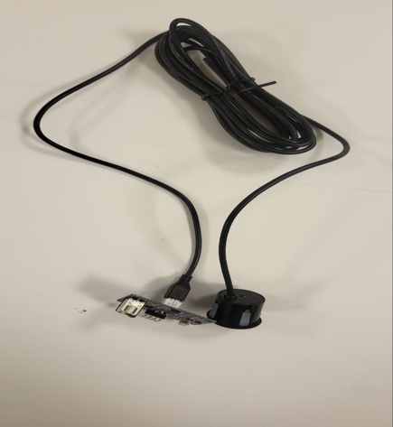  ultrasonic
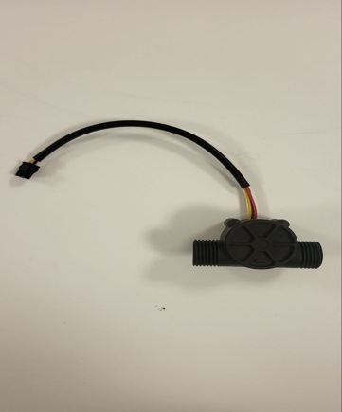  Water flow sensor | 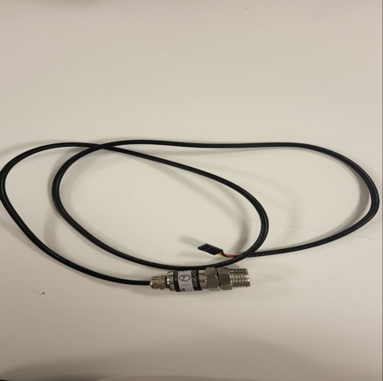  Water pressure sensor | 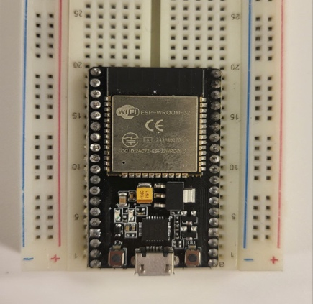  Esp32 controller

Coding:
As mentioned before 4 esp32s were used in this project containing 1 main Esp32 and 4 slave Esp32s
The following is the main Esp32 control source code
The rest of the codes can be found on : source code
#include "MainController.h"
#include "DataTypes.h"

extern UARTLink_Esp32_1 link1;
extern UARTLink_Esp32_2 link2;
extern UARTLink_Esp32_3 link3;
extern I2CCommCam camComm;

MainController::MainController()
: _lastUpdateMs(0), _timeStepSec(0.01f) // default 10ms
{
// Initialize submarine state to 0
memset(&_subState, 0, sizeof(Submarine_State));

// Initialize environment state
memset(_envState.occupancyGrid, false, sizeof(_envState.occupancyGrid));
_envState.resolution = 10.0f; // cm per cell
_envState.centerX = 0.0f; // initial world center
_envState.centerY = 0.0f;
_envState.centerZ = 0.0f;

// Initialize path
_currentPath.isNew = false;

// Initialize XY PID
initPID(_xyPid, /*kp=*/1.0f, /*ki=*/0.0f, /*kd=*/0.0f);
}

void MainController::begin()
{
_lastUpdateMs = millis();
}

void MainController::update()
{
// 1) Calculate delta time
unsigned long now = millis();
float dt = (now - _lastUpdateMs) / 1000.0f;
if (dt <= 0.0f)
dt = _timeStepSec; // fallback if something weird
_lastUpdateMs = now;

// 2) Read from ESP32-1: IMU data
IMU_MPU6050_Data imuData;
if (readDataFromESP32_1_Imu(imuData))
{
updateSubmarineStateFromIMU(imuData, dt);
}

// 3) Possibly read from ESP32-1: Sonar sweep data
// If available, update occupancy grid
SonarScanData sonarData;
if (readDataFromESP32_1_Sonar(sonarData))
{
updateOccupancyGridFromSonar(sonarData);
}

// 4) Read from ESP32-2: doppler, pressure, flow
Esp32_2_Data data2;
if (readDataFromESP32_2(data2))
{
// We can do something with doppler speed, pressure, flow here if needed
// e.g. doppler speed might refine velocity measure, etc.
// We keep it simpler.
}

// 5) Check if a new path arrived from ESP32-CAM
PathData newPath;
if (readPathFromCam(newPath))
{
// If there's a new path, store it
if (newPath.isNew)
{
// Potentially adjust or re-calc
adjustPath(newPath);
_currentPath = newPath;
_currentPath.isNew = false;
// Also reset XY PID
resetPID(_xyPid);
}
}

// 6) If shifting grid is needed because sub is out of boundary, do it
shiftGridIfNeeded();

// 7) Follow path logic => produce commands to motors/pumps
followPathAndProduceCommands(dt);

// 8) Send Submarine_State + Env_State to CAM
MainToCamData camData;
camData.subState = _subState;
camData.envState = _envState;
writeDataToCam(camData);
}

/*=============================================================================
* 1) Communication Stubs
*============================================================================*/
bool MainController::readDataFromESP32_1_Imu(IMU_MPU6050_Data &imuData)
{
// ask link1 if it has new IMU
return link1.getImuData(imuData);
}

bool MainController::readDataFromESP32_1_Sonar(SonarScanData &sonarData)
{
// ask link1 if it has new sonar
return link1.getSonarData(sonarData);
}

bool MainController::readDataFromESP32_2(Esp32_2_Data &data)
{
return link2.getData(data);
}

bool MainController::writeCommandToESP32_3(const Esp32_3_Command &cmd)
{
link3.sendCommand(cmd);
return true;
}

bool MainController::readPathFromCam(PathData &path)
{
// Attempt to read from camComm
// returns true if we got new data
return camComm.getPathData(path);
}

bool MainController::writeDataToCam(const MainToCamData &msg)
{
return camComm.sendMainToCam(msg);
}

/*=============================================================================
* 2) Update Submarine State from IMU
* This merges the linear accel with velocity, position, etc.
*============================================================================*/
void MainController::updateSubmarineStateFromIMU(const IMU_MPU6050_Data &imu, float dt)
{
// Update submarine acceleration from IMU
_subState.accelX = imu.accelX;
_subState.accelY = imu.accelY;
_subState.accelZ = imu.accelZ;
// Integrate velocity
_subState.velX += _subState.accelX * dt;
_subState.velY += _subState.accelY * dt;
_subState.velZ += _subState.accelZ * dt;
// Integrate position
_subState.posX += _subState.velX * dt + 0.5f * _subState.accelX * dt * dt;
_subState.posY += _subState.velY * dt + 0.5f * _subState.accelY * dt * dt;
_subState.posZ += _subState.velZ * dt + 0.5f * _subState.accelZ * dt * dt;

// Update gyro
_subState.gyroX = imu.gyroX;
_subState.gyroY = imu.gyroY;
_subState.gyroZ = imu.gyroZ;

// For roll/pitch/yaw, we do a naive integration (assuming gyro in rad/s):
_subState.roll += _subState.gyroX * dt;
_subState.pitch += _subState.gyroY * dt;
_subState.yaw += _subState.gyroZ * dt;
}

/*=============================================================================
* 3) Occupancy Grid from Sonar
*============================================================================*/
void MainController::updateOccupancyGridFromSonar(const SonarScanData &sonar)
{
// We have angles from -60 to +60, step=sonar.angleResolution
// For each measurement i:
// angle_i = -60 + i*angleResolution
// distance_i = sonar.distances[i]
// Convert (angle, distance) to a world coordinate (assuming heading = yaw)
// then set occupancyGrid[...] = 1 for that cell.

float headingRad = _subState.yaw; // submarine's yaw in radians

for (uint16_t i = 0; i < sonar.numMeasurements && i < SonarScanData::MAX_NUM_MEASUREMENTS; i++)
{
float dist = sonar.distances[i];
float angleDeg = -60.0f + i * sonar.angleResolution; // example
float angleRad = angleDeg * 3.14159f / 180.0f;

if (dist < 0)
{
// Means no obstacle => we can set all cells up to max range as free
// For now, we do nothing or we can mark them free
// if we want to 'clear' that sector. Implementation choice.
continue;
}

// Convert local polar (angleRad, dist) -> local X/Y
float localX = dist * cos(angleRad);
float localY = dist * sin(angleRad);
// We ignore Z for now, or we can consider a horizontal plane.
// For advanced 3D, you'd need pitch as well, or some known sensor orientation.

// Then rotate by submarine's heading
float globalX = _subState.posX + (localX * cos(headingRad) - localY * sin(headingRad));
float globalY = _subState.posY + (localX * sin(headingRad) + localY * cos(headingRad));
float globalZ = _subState.posZ; // we do not track vertical angle for now, or we can do if we have tilt data

// Mark that position as occupied
setOccupancyByWorldPos(globalX, globalY, globalZ, true);
}
}

void MainController::setOccupancyByWorldPos(float worldX, float worldY, float worldZ, bool occupied)
{
// 1) Convert from world coords => grid index
// delta = worldPos - envState.center
float dx = worldX - _envState.centerX;
float dy = worldY - _envState.centerY;
float dz = worldZ - _envState.centerZ;

// in "cell units"
float cellX = dx / _envState.resolution + GRID_CENTER;
float cellY = dy / _envState.resolution + GRID_CENTER;
float cellZ = dz / _envState.resolution + GRID_CENTER;

int ix = (int)roundf(cellX);
int iy = (int)roundf(cellY);
int iz = (int)roundf(cellZ);

// 2) check bounds
if (ix < 0 || ix >= GRID_SIZE ||
iy < 0 || iy >= GRID_SIZE ||
iz < 0 || iz >= GRID_SIZE)
{
// out of bounds
return;
}

// 3) set occupancy
_envState.occupancyGrid[ix][iy][iz] = occupied;
}

/*=============================================================================
* 3b) Shift the grid if submarine goes out of bounds
*============================================================================*/
bool MainController::shiftGridIfNeeded()
{
// find sub's cell index
float dx = _subState.posX - _envState.centerX;
float dy = _subState.posY - _envState.centerY;
float dz = _subState.posZ - _envState.centerZ;

int ix = (int)roundf(dx / _envState.resolution) + GRID_CENTER;
int iy = (int)roundf(dy / _envState.resolution) + GRID_CENTER;
int iz = (int)roundf(dz / _envState.resolution) + GRID_CENTER;

int shiftX = 0;
int shiftY = 0;
int shiftZ = 0;

// We want sub's cell index to remain within [0..24].
// If ix < 0 => shift + 1
// If ix > 24 => shift - 1
// But it's not just 1; we want to shift enough so that ix is back near center
// We'll do a simpler approach: if ix < 2 => shift + (some cells)
// if ix > 22 => shift - (some cells)
// For example, we might shift 12 cells so sub gets back to the center
int lowerBoundary = 2;
int upperBoundary = GRID_SIZE - 3; // 22 if 25

if (ix < lowerBoundary)
{
shiftX = (GRID_CENTER - ix); // so sub is near center again
}
else if (ix > upperBoundary)
{
shiftX = (GRID_CENTER - ix);
}
if (iy < lowerBoundary)
{
shiftY = (GRID_CENTER - iy);
}
else if (iy > upperBoundary)
{
shiftY = (GRID_CENTER - iy);
}
if (iz < lowerBoundary)
{
shiftZ = (GRID_CENTER - iz);
}
else if (iz > upperBoundary)
{
shiftZ = (GRID_CENTER - iz);
}

if (shiftX == 0 && shiftY == 0 && shiftZ == 0)
{
return false; // no shift needed
}

shiftGrid(shiftX, shiftY, shiftZ);

// Also shift center in real-world coords
float shiftWorldX = -(shiftX * _envState.resolution);
float shiftWorldY = -(shiftY * _envState.resolution);
float shiftWorldZ = -(shiftZ * _envState.resolution);

_envState.centerX += shiftWorldX;
_envState.centerY += shiftWorldY;
_envState.centerZ += shiftWorldZ;

return true;
}

void MainController::shiftGrid(int dx, int dy, int dz)
{
// Shifting 3D array by dx,dy,dz
// We'll create a temp array, fill it with false, then copy the old data
// to the new location in the temp array, then copy back.

static bool tempGrid[GRID_SIZE][GRID_SIZE][GRID_SIZE];

memset(tempGrid, false, sizeof(tempGrid));

for (int x = 0; x < GRID_SIZE; x++)
{
for (int y = 0; y < GRID_SIZE; y++)
{
for (int z = 0; z < GRID_SIZE; z++)
{
int nx = x + dx;
int ny = y + dy;
int nz = z + dz;
if (nx >= 0 && nx < GRID_SIZE &&
ny >= 0 && ny < GRID_SIZE &&
nz >= 0 && nz < GRID_SIZE)
{
tempGrid[nx][ny][nz] = _envState.occupancyGrid[x][y][z];
}
}
}
}

// copy back
memcpy(_envState.occupancyGrid, tempGrid, sizeof(tempGrid));
}

/*=============================================================================
* 4) Path Logic
*============================================================================*/
void MainController::adjustPath(PathData &path)
{
// This is a placeholder for advanced path “pre-processing”
// E.g. checking for immediate obstacles, etc.
// For now, do nothing
}

void MainController::followPathAndProduceCommands(float dt)
{
if (_currentPath.waypoints.empty())
{
// No path => maybe stop motors
Esp32_3_Command cmd;
cmd.esc1_us = 1500; // neutral
cmd.esc2_us = 1500; // neutral
cmd.pumpCmd = PumpFlowCmd::OFF;
writeCommandToESP32_3(cmd);
return;
}

// 1) Look at next waypoint
Waypoint &wp = _currentPath.waypoints.front();
float distX = wp.x - _subState.posX;
float distY = wp.y - _subState.posY;
float distZ = wp.z - _subState.posZ;
float distSq = distX * distX + distY * distY + distZ * distZ;
float threshold = 10.0f; // e.g. 10 cm

if (distSq < (threshold * threshold))
{
// We consider we "reached" it
_currentPath.waypoints.erase(_currentPath.waypoints.begin());
if (_currentPath.waypoints.empty())
{
// done
Esp32_3_Command cmd;
cmd.esc1_us = 1500;
cmd.esc2_us = 1500;
cmd.pumpCmd = PumpFlowCmd::OFF;
writeCommandToESP32_3(cmd);
return;
}
}

// Re-read front if we popped
if (!_currentPath.waypoints.empty())
{
Waypoint &wpNext = _currentPath.waypoints.front();
// Compute X-Y control
float esc1_us = 1500, esc2_us = 1500;
computeXYControl(wpNext.x, wpNext.y, dt, esc1_us, esc2_us);

// Compute depth
PumpFlowCmd pumpCmd = computeDepthCommand(wpNext.z, _subState.posZ, /*threshold=*/10.0f);

// Send
Esp32_3_Command cmd;
cmd.esc1_us = (uint16_t)esc1_us;
cmd.esc2_us = (uint16_t)esc2_us;
cmd.pumpCmd = pumpCmd;
writeCommandToESP32_3(cmd);
}
}

/*=============================================================================
* 5) XY PID
* We'll do a simple 2D approach: if we want to go from (posX,posY) to
* (desiredX,desiredY), we treat the difference as error. Then we produce
* a differential throttle for ESC1/ESC2.
*============================================================================*/
void MainController::initPID(PID_Controller &pid, float kp, float ki, float kd)
{
pid.kp = kp;
pid.ki = ki;
pid.kd = kd;
pid.integratorX = 0.0f;
pid.integratorY = 0.0f;
pid.prevErrorX = 0.0f;
pid.prevErrorY = 0.0f;
pid.prevTimeMs = millis();
}

void MainController::resetPID(PID_Controller &pid)
{
pid.integratorX = 0.0f;
pid.integratorY = 0.0f;
pid.prevErrorX = 0.0f;
pid.prevErrorY = 0.0f;
pid.prevTimeMs = millis();
}

void MainController::computeXYControl(float desiredX, float desiredY, float dt, float &esc1_us, float &esc2_us)
{
// Error is difference
float errX = desiredX - _subState.posX;
float errY = desiredY - _subState.posY;

// For simplicity, we do the same PID for X and Y (like a 2D approach)
// ignoring heading. A more advanced approach would be to transform error
// into forward-lateral relative to sub heading.

// P
float pX = _xyPid.kp * errX;
float pY = _xyPid.kp * errY;

// I
_xyPid.integratorX += errX * dt;
_xyPid.integratorY += errY * dt;
float iX = _xyPid.ki * _xyPid.integratorX;
float iY = _xyPid.ki * _xyPid.integratorY;

// D
float dX = _xyPid.kd * (errX - _xyPid.prevErrorX) / dt;
float dY = _xyPid.kd * (errY - _xyPid.prevErrorY) / dt;

float outX = pX + iX + dX;
float outY = pY + iY + dY;

_xyPid.prevErrorX = errX;
_xyPid.prevErrorY = errY;

// We'll interpret outX as forward/reverse throttle, outY as left/right differential
// Then ESC1 = base + diff, ESC2 = base - diff.
// "base" is 1500 (neutral). We'll do a simple scale so that max is ±500 => [1000..2000].
float maxOutput = 500.0f;
outX = clamp(outX, -maxOutput, maxOutput);
outY = clamp(outY, -maxOutput, maxOutput);

float base = 1500.0f;
// We can combine X and Y in some manner
// forward = outX => add to both ESC
// rotate = outY => add to one side, subtract from other

float left = base + outX + outY;
float right = base + outX - outY;

// clamp
left = clamp(left, 1000.0f, 2000.0f);
right = clamp(right, 1000.0f, 2000.0f);

esc1_us = left;
esc2_us = right;
}

/*=============================================================================
* 6) Depth Logic
*============================================================================*/
PumpFlowCmd MainController::computeDepthCommand(float desiredZ, float currentZ, float threshold)
{
float diff = desiredZ - currentZ;
if (diff > threshold)
{
// sub is above desired => we want to go deeper => pump water in
return PumpFlowCmd::IN;
}
else if (diff < -threshold)
{
// sub is below desired => we want to go shallower => pump water out
return PumpFlowCmd::OUT;
}
// within threshold => do nothing
return PumpFlowCmd::OFF;
}

/*=============================================================================
* Utility
*============================================================================*/
float MainController::clamp(float val, float minVal, float maxVal)
{
if (val < minVal)
return minVal;
if (val > maxVal)
return maxVal;
return val;
}

- Ultrasonic Sensor: Calculates distance by sending sound waves and measuring their return time.
- Water Flow Sensor: Measures the flow rate using interrupt-driven pulse counting.
- Water Pressure Sensor: Reads analog signals, converts to voltage, and computes pressure in MPa.
- MPU6050: Reads accelerometer and gyroscope data for orientation and motion tracking.

Assembly of the Submarine Project
The assembly of the submarine project involved combining the 3D-printed components, integrating sensors, and ensuring that the entire structure was functional and waterproof. While the process was rewarding, it presented several challenges that required creative problem-solving and iterative improvements. Below is a detailed account of the assembly process, the issues faced, and the solutions we implemented.

1. Preparing the 3D-Printed Structure
The submarine's body was designed and printed using advanced 3D modeling software. The printing process provided a durable and lightweight structure, but the next step was assembling the individual components into a cohesive body:
Challenge:
Gluing the parts together was difficult because the structure needed to remain flexible while still being strong enough to hold all components.
Solution:
We used a combination of waterproof adhesives and melting techniques to bond the parts. Flexibility was achieved by carefully controlling the amount of adhesive applied, ensuring strong joints without compromising the structural integrity.

2. Adding Holes for Sensor Integration
To integrate sensors such as the camera, HB100 (doppler radar), and ultrasonic sensor, we needed to create precise openings in the submarine’s body.
Challenge:
Drilling or cutting the holes in the 3D-printed material proved tricky. Some sensors required snug fits, and the material's thickness sometimes caused alignment issues.
Solution:
We used precision tools to cut and smooth the holes. For irregular-shaped sensors, we used plastic inserts and bonded them into the holes using glue and a melting technique. This ensured a tight and secure fit for each sensor, minimizing water ingress.

3. Sensor Wiring and Integration
The sensors needed to be connected to the ESP32 controller, which required intricate wiring and careful management of space within the submarine.
Challenge:
The wiring was complex and took up a significant amount of space, making it difficult to arrange the components neatly. Additionally, some wires disconnected during the assembly process, which delayed progress.
Solution:
We labeled each wire and used heat-shrink tubing to organize and secure the connections. Zip ties and adhesive mounts were used to fix the wiring to the interior walls, preventing them from tangling or becoming loose. We tested each sensor individually after installation to ensure functionality.

4. Waterproofing
Ensuring the submarine was completely waterproof was one of the most critical parts of the assembly process.
Challenge:
The biggest concern was preventing water from seeping into the body through the joints, sensor holes, and wiring entry points. Even small gaps could compromise the submarine’s operation underwater.
Solution:
For the sensor openings, we used rubber gaskets and waterproof sealants to encapsulate the exposed areas.
For joints and seams, we applied multiple layers of waterproof adhesive and tested for leaks by submerging the structure in water.
For wiring entry points, we used plastic bottles as enclosures to encapsulate the sensitive electronic components. This provided an additional layer of protection by isolating the electronics from direct exposure to water.

Wiring Diagram for Sensors

The diagram meticulously outlines the connections between all sensors, actuators, and the control systems.
L298 Motor Driver: Used to control the pumps (via switches) for precise movement and water flow management.
Pump Switches: Incorporated to toggle the operation of the pumps, which regulate buoyancy and water flow.
Sensors: Includes connections for various sensors like the HB100 (Doppler radar), water pressure sensor, ultrasonic sensor, and more, ensuring their correct integration with the ESP32.
Communication Pins: Clearly shows the TX/RX connections for serial communication, which is essential for data transmission between different parts of the system.

2. Contributions of the Diagram
Accurate Wiring:
The detailed connections helped ensure the L298 driver was properly configured to operate the two pump switches without errors. Miswiring of this critical component could have led to malfunction or system failure, but the diagram prevented such issues.
Team Collaboration:
The diagram was a result of excellent teamwork, where members collaborated to identify, document, and organize all connections. This collective effort streamlined the assembly process and reduced errors.
Efficient Troubleshooting:
During the testing phase, the diagram served as a reference to debug and resolve any wiring-related problems. For example, any misalignment in sensor wiring or communication pins was quickly identified and corrected.
Improved Understanding:
The visual representation enhanced the team's understanding of the system's layout and functionality. It allowed each team member to confidently work on specific components without confusion.

3. Integration of L298 Driver with Pump Switches
The L298 motor driver was crucial for controlling the pumps, which manage the submarine's buoyancy by moving water in and out of the system.
Challenges:
Initial difficulties arose in wiring the pumps correctly to the L298 driver.
Ensuring the driver received the correct signals to control the pumps effectively was another challenge.
Solution:
Thanks to the contributions of the team and the wiring diagram, the connections were correctly mapped out. This allowed the pumps to operate smoothly, controlled by the driver via the ESP32.
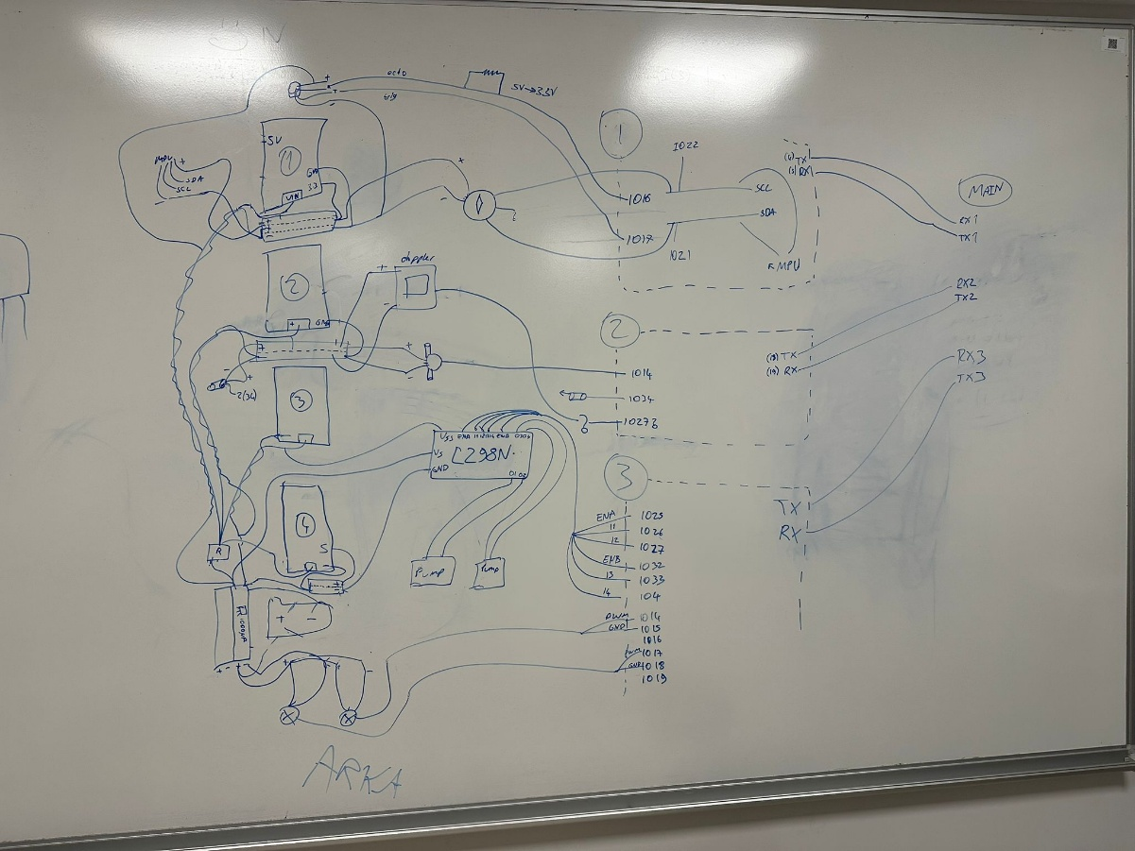

Communication

Communication and Security Implementation in Our Project
From our side, we have carefully designed, tested, and implemented communication protocols and security measures to ensure reliable and safe operation of the submarine. This includes the integration of multiple sensors with the ESP32 and the use of robust communication protocols for remote monitoring and control. Below is a detailed account of our approach:

1. Communication Between Sensors and ESP32
We successfully connected a variety of sensors to the ESP32 microcontroller, each using a specific communication protocol:
Analog Communication (ADC): Used for sensors like the water pressure and flow sensors. We tested their output stability and calibrated the ADC readings to ensure accurate data.
I2C Protocol: Used for the MPU6050 (IMU) and BMM150 (Magnetometer). During testing, we ensured the correct address mapping and resolved potential conflicts by verifying each sensor's address.
UART Protocol: Utilized for the HB100 Doppler radar and ultrasonic sensors. We tested multiple UART connections, ensuring proper data transmission without interference or data loss.
These protocols allowed seamless integration of the sensors, enabling the ESP32 to collect and process data effectively.

2. Wireless Communication with ESP32
For external communication, we opted for both Wi-Fi and Bluetooth protocols, which we tested thoroughly:

Wi-Fi Communication
We used Wi-Fi to enable real-time data transmission to remote systems. The ESP32 connected to a secured Wi-Fi network, and we set up an HTTP server on the ESP32 for remote monitoring.
Testing:
The HTTP endpoints were tested to ensure stable data retrieval.
Sensor data was sent to a remote server using an encrypted HTTPS connection, which we confirmed provided secure data transfer.
Protocol: HTTP for easy integration with web interfaces and MQTT for lightweight, real-time messaging.

3. Security Measures
Ensuring secure communication was a top priority during the project. Here are the steps we implemented:

Sensor Connection Security
We encapsulated all sensor connections using waterproof enclosures to prevent water ingress, which we tested in submerged conditions.
To minimize noise and interference, we used shielded cables for sensitive analog sensors and implemented signal filtering in the ESP32 software.

Wireless Communication Security
For Wi-Fi, we used WPA2 encryption for network access and configured the ESP32 to use HTTPS for secure communication.
For MQTT, we configured the broker with:
Username/password authentication to prevent unauthorized access.
TLS encryption to secure the communication between the ESP32 and the broker.
For Bluetooth, we enabled encryption and pairing authentication to ensure secure connections with authorized devices only.

Preventing Unauthorized Access
We implemented access control mechanisms, such as limiting access to specific IP addresses for Wi-Fi communication.
The ESP32 firmware was secured using secure boot and code signing, ensuring the firmware could not be tampered with.

4. Challenges and Solutions
During testing, we faced several challenges:
Challenge: Noise interference in analog signals.
Solution: Added smoothing capacitors and implemented signal filtering in the ESP32 firmware.
Challenge: Address conflicts with I2C sensors.
Solution: Re-mapped addresses and tested communication individually before integrating.
Challenge: Ensuring waterproof connections for sensors and wiring.
Solution: Used plastic enclosures and sealants, which were rigorously tested during submersion.
Challenge: Securing remote communication.
Solution: Configured SSL/TLS encryption for HTTP and MQTT protocols, ensuring data integrity and security.

Results and Discussion

Performance Analysis
The submarine performed exceptionally well during controlled tests, demonstrating the effectiveness of its design and the seamless integration of its components. The ultrasonic sensors proved invaluable in detecting and avoiding obstacles, while the pressure sensor provided accurate depth readings that were essential for underwater navigation. Overall, the submarine’s performance exceeded expectations, validating the design and implementation choices made throughout the project.

Challenges Faced
- Brushless Motor: We faced significant challenges with the brushless motor, particularly in achieving precise control for efficient operation. The issues were addressed by optimizing the motor control algorithm and ensuring compatibility with the ESC (Electronic Speed Controller), resulting in improved performance and reliability.
- Limited GPIO Pins: The ESP32 microcontroller’s limited GPIO pins required careful management and planning to accommodate all sensors and components. This challenge was overcome through strategic pin allocation and efficient coding practices.
- Hardware Malfunctions: Issues such as wiring errors and sensor failures were addressed through collaborative troubleshooting and iterative testing, ensuring the system’s overall reliability.

Sensor Effectiveness
- Ultrasonic Sensors: Provided precise and reliable distance measurements, facilitating safe navigation and obstacle avoidance.
- Pressure Sensor: Delivered accurate depth data, enabling effective underwater operation and navigation.
- Radar Sensor: Successfully detected obstacles within its range, contributing to the submarine’s overall safety and efficiency.
- Magnetometer: Assisted in maintaining directional stability and orientation, enhancing the submarine’s navigational capabilities.
- Flow Sensor: Ensured proper functionality of the propulsion system by monitoring water flow rates and performance metrics.

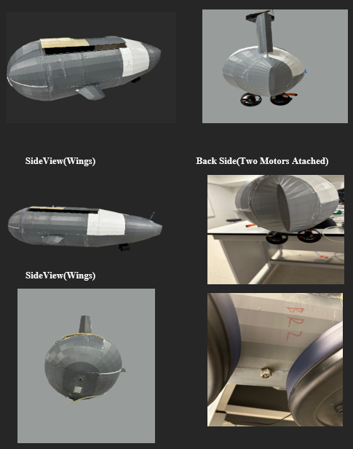
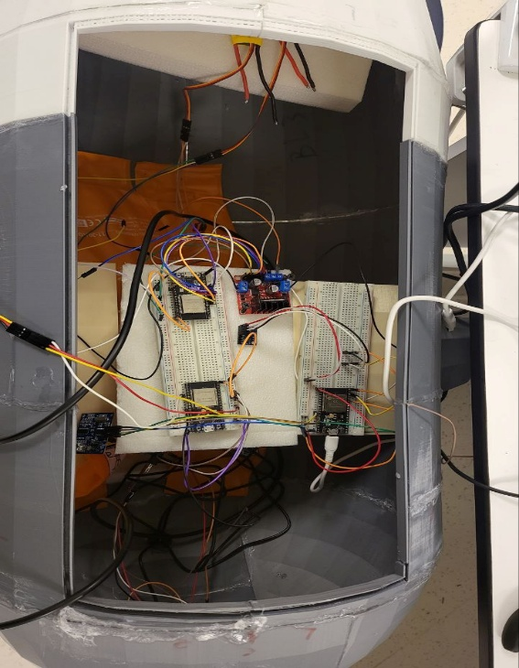
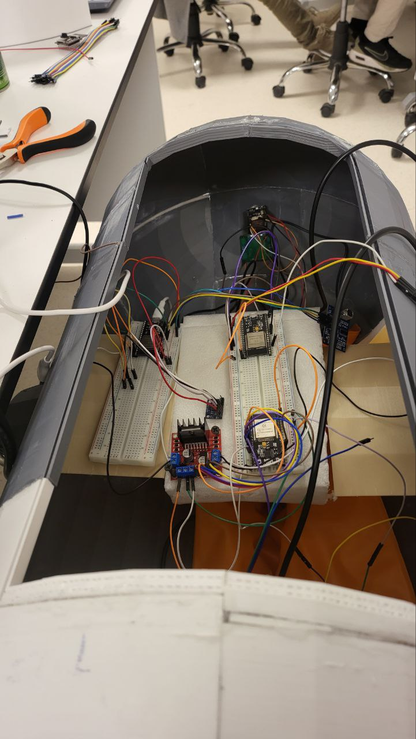
Front Side (Camera,Dopler,Ultrasonic) Bottom Side (Water Pressure Sensor

7. conclusion
By selecting the right amount and identity of the sensors, make the right connection with the convenient number of esp32s and connections brtween esp32s and sensors, by making the design and sticking the sensors in their correct places, wlso by adding w camera to check everywhere around the front side of the submarine, the submarine project can be considered finished wnd ready for testing as soon as possible
This submarine robotics project successfully demonstrated the potential of AUVs for challenging underwater tasks. The integration of advanced sensors and robust systems laid the foundation for future improvements. This project serves as a stepping stone toward sustainable and innovative marine exploration technologies.

